Powerful Conversations – Session 2 – Workload & Performance Management

Fire & Rescue NSW Performance Partnering Example
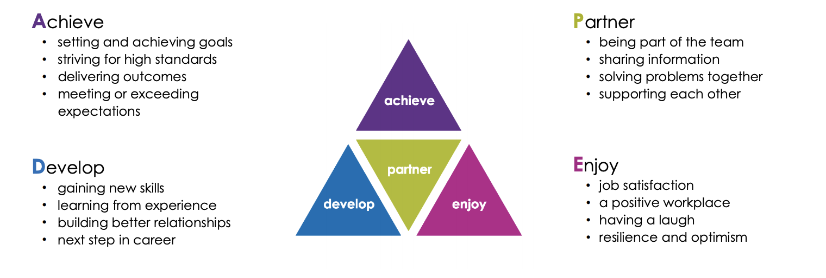
Task 1 – How do you engage with your team?
In your peer groups outline your team performance management process:
- Is your process structured or unstructured
- What is the timeframe, 6 monthly/Annually.
- Does the process impact on promotion or progression
- How well does your system work?

Task 2 – How do you manage workloads?
Workload Management – Job Demand v Job Control
- Do you have sufficient staff and resources?
- Are you and your people empowered to solve problems
- What are the difference demands between proactive and reactive work?

Task 3 – How do you recognise achievements and address performance problems

Scenario A
You receive a call from a peer from another work area, one of your team stopped and assisted him and his wife, after his wife was involved in a bicycling accident, while off duty. Your peer was very complementary about the professionalism displayed by the team member.

- Develop a script to recognise a positive outcome
  - How is this recognition shared and acknowledged?
  - What systems could you use to promote positive outcomes

Scenario B
A member of your team joined the rest of your crew to watch a game of football while on shift, this was a welcome act as the team member usually keeps to themselves when at work. The team member was passionately supporting his team however his language was not appropriate for the workplace.

- Develop a script to address substandard outcomes
  - How and where is this conversation conducted
  - How is this feedback recorded and tracked?

